Framework for Customer Behavior Tracking Within

Retail Stores

***Abstract*—This paper presents a framework for analyzing customer behavior within hypermarkets using advanced object detection models. The presented framework aims to determine optimum product placement within retail stores, aiding supermarket vendors in optimizing product sales. The framework also provides retail store owners with interactive reports and a virtual dashboard for customizing each shelf to predict product sales based on historical data. The final output is designed to be user-friendly and easy to digest with minimal technological or analytical knowledge.**

***Keywords— Computer Vision, AI, Behavior Analysis, Human Behavior, Digital Media, Retail Stores.***

# Introduction

In order to maximize the amount of products sold, supermarkets have used dated marketing philosophies to place products around their stores for efficient selling. Although these philosophies have proven moderately successful, they fail to acknowledge the evolving needs of customers and the change in their buying psychologies. Because customer needs and behaviors are constantly changing, a dynamic solution must be presented to adapt product placements based on these evolving changes.

A paper was published a while ago, in 2009, titled *Pedestrian Static Trajectory Analysis of a Hypermarket*, was one of many firsts to prove the efficiency and significance of customer behavior analysis through trajectory tracking for better decision making[1]. Along with the advancement of store surveillance systems coupled with object detection softwares, it has proven to be much more effective to use customized customer traffic and trajectory-based solutions to determine the optimum placement for products within retail stores. The idea behind these systems has been developed in many research papers spanning the field of Computer Science and Marketing alike, but only recently has the technology been available to efficiently study and implement these systems on a large scale.

Previously, many implementations of this concept have been applied and researched. These include works by Hernandez et al., S.Peker et al., and several others to be discussed in the upcoming sections. Having proven to be effective systems, the proposed solutions did not provide business owners with clear, easily digested reports on the proper proposed placement of products.

The proposed framework being presented would solve the problems past research has failed to solve, building upon stronger object detection algorithms, providing interactive reports for retail store owners, and customizing each shelf based on a virtual, interactive dashboard amongst many other further plans. This complete system would provide retail store owners with the correct evidence to support a new, dynamic solution to product placement within their stores. The system would be non-invasive to the store, needing only access to the footage from the store’s CCTV cameras, as demonstrated in *Figure 5* of the System Overview, meaning its installation is easier on retail store owners, bypassing any physical intrusions.

1. *Human Behavior*

As a starting point, human behavior was classified to be the behavioral motions human customers exhibit when traversing within supermarket facilities. The behaviors focussed on were behaviors centered around reactions and possible interactions with products placed on supermarket shelves.

The three behaviors studied were customer passing-by, customer impression, and customer dwelling. A passer-by is defined as the absence of any remarks towards a product on a shelf and simply passing by without giving it notice. As seen in *Figure 1*, the pedestrian selected in the dark blue framed detector was detected as a passer-by in the footage since the person took a short amount of time to look at each product, which is also the parameter in this research’s model. Just as well, the woman on the bottom left in *Figure 2* of the same dataset was also detected as a passer-by as she was walking while looking at her phone. As opposed to the act of impression, which is defined as customers suddenly pausing and stopping in front of a certain product after taking notice of it. In the same *Figure 1*, the pedestrian in the red framed detector stops to look at the shelves for a longer while than the passerby did. The person paused with little movement. However no products were picked up which would suggest the strong help of the eye gaze detection in future work, currently being worked on. Moreover, customer dwelling is defined as a shopper’s observation leading to an extension of their stay at a certain point in front of a shelf. To dwell on a product would demand spending a long amount of time fixated on one shelf, which was not present in that case. *Figure 3* accurately portrays that instance in the red framed person located in the bottom left. Further actions such as bending over, reaching for products and returning products are to be added. In *Figure 6* for instance, the footage showcased the person in the yellow frame to be returning a product to the shelf.

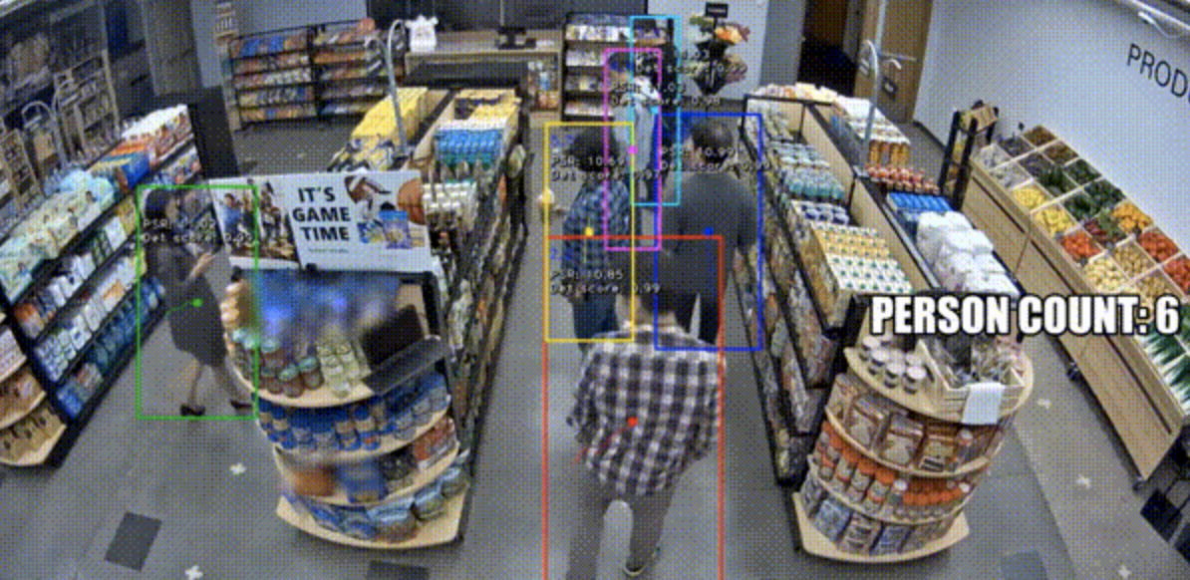

*Figure 1*

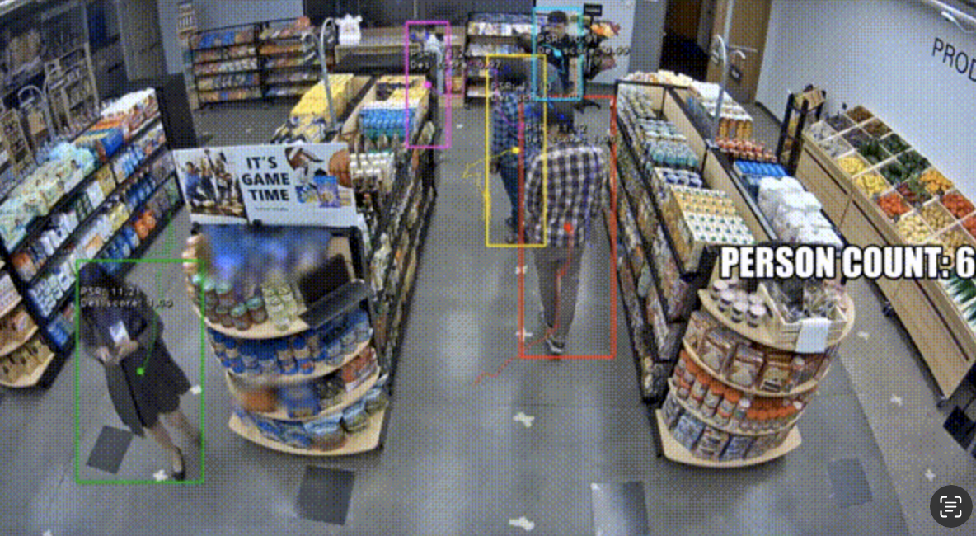

*Figure 2*

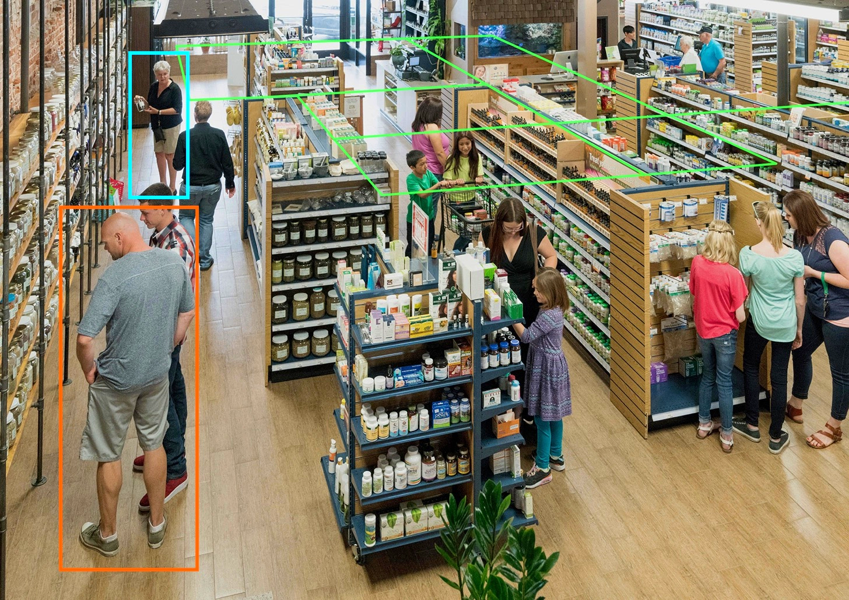

*Figure 3*

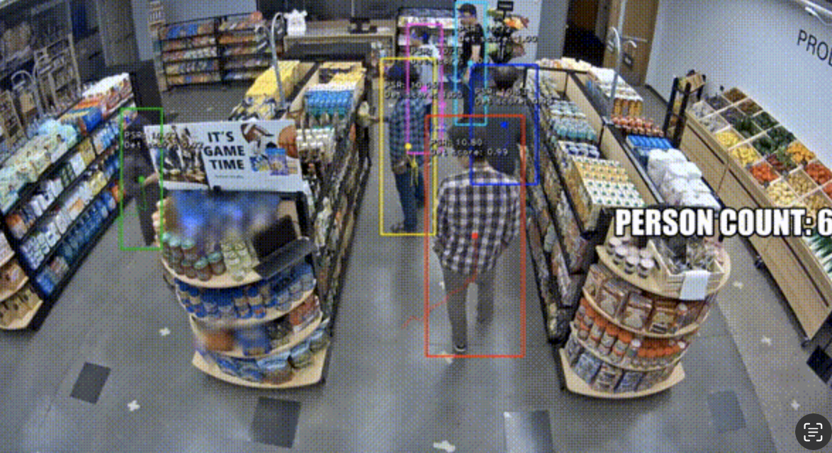

*Figure 4*

1. *Behavior Tracking and Analysis*

In order to interpret the defined customer behaviors, precise computer vision algorithms were applied on the extracted CCTV footage from the vendors’ stores. To be discussed in further detail within the *Methodology* section,, the models used were YOLO v7, DBSCAN, and the Markov model. With each of the models presenting a unique value proposition, a combination of all three was applied. Because of their outdated shortcomings, further research is to be conducted on more modern algorithms for the application. Other frameworks were implemented such as the Spatial Analysis model published on Microsoft Azure[2], as shown in *Figure 1*.

Analysis on extracted behaviors is presented as the trends and averages of the types of behaviors exhibited when next to certain products. The decisions could then be made based on product quality of choice of placement.

1. *Research Objective*

Within the scope of the research at hand, the objective with this project is to provide supermarket and hypermarket vendors with a capable software that helps excel their product placements and positively affect overall product sales.

As researchers, the aim with the research conducted is to determine the most effective use of available computer vision and machine learning models within the field of customer behavioral analysis. The aim is to bear fruitful results and contribute to the scientific community with findings that point to modest yet proven results that have the ability to advance the field of computer vision focused on customer behavior based on the research conducted.

As a secondary aim, future work is to be noted through each step of the research methodology in order to set a roadmap for future research within the computer vision field.

# Related Work

With the rise of technological advancements in the Artificial Intelligence field, many notable research bodies of work have been conducted to further analyze visual customer behavior streams. Among the key works in this domain is the paper published on Research Gate and titled *Customer Analysis via Video Analytics: Customer Detection with Multiple Cues[3]*. It discussed the implementation of the DbScan and Markov models in order to focus on the timings and repetitiveness of events. It explores additional cues for customer detection through context, prior knowledge and sensory input such as videos. The framework proved a success for the business establishment with a 42% increase in performance.

Furthermore, another study titled *How Computer Vision Provides Physical Retail[4] with a Better View on Customers* collects insight through customer trajectory from entry to exit. A mapping of the physical story is utilized in order to monitor item placements. The research suggested the use of the YOLO algorithm alongside additional optimization efforts; such as positioning and improved shelving procedures. Many papers in this topic however discuss the limitations of such analysis when it comes to customer privacy or data breaches. Certainly there exists a solution to these shortcomings given the beneficial value.

In addition, extensive research is mandatory to take place in order to achieve the most optimized results for our framework. The following related work, titled *An empirical comparison of customer behavior modeling approaches for shopping list prediction[5]* compares different customer behavior modeling approaches for predicting purchases. It incorporates for instance multiple methods for segmentation in order to select the most accurate modeling approach. It is fixated on utilizing three features which are “average inter-purchasing time”, “average basket size” and “product variety”. Many models are discussed and examined in this paper which proves to be valuable for the preliminary research of the framework’s demo and future implementation.

# Methodology

To ensure a stable flow of data from collection to analysis to final output, a structured methodology was devised.

## Data Harvesting

In order to train the models used for behavior analysis, a database of customer movement was created in a controlled library environment to mimic customer behaviors within retail stores. The movements included bending over, reaching for a product, dwelling in front of a product, and the lack of any attention towards a product.

When implementing the software within a functional retail store, the data collection will be done by extracting video footage from the in-store CCTV cameras in order to ensure a fixed, stable view of customers within the retail store. Due to the lack of online datasets of CCTV cameras in 720p or higher quality of the same store, the curation of an original dataset was necessary. Just as well, many applications for hypermarkets in Egypt were sent with replies that are following through to be used in the ongoing process of improving the framework.

## Preprocessing

As seen in the System Overview [*Figure 5*], the system embeds a preprocessing tunnel for the dataset utilized. The first step is to remove all the backgroung noise per frames. Followed by detecting the occlusions and cleaning the datasets from the duplicated information stating said occlusions by either correcting or leaving them. Lastly generating heatmaps with the most populated spots within an hourly timeframe.

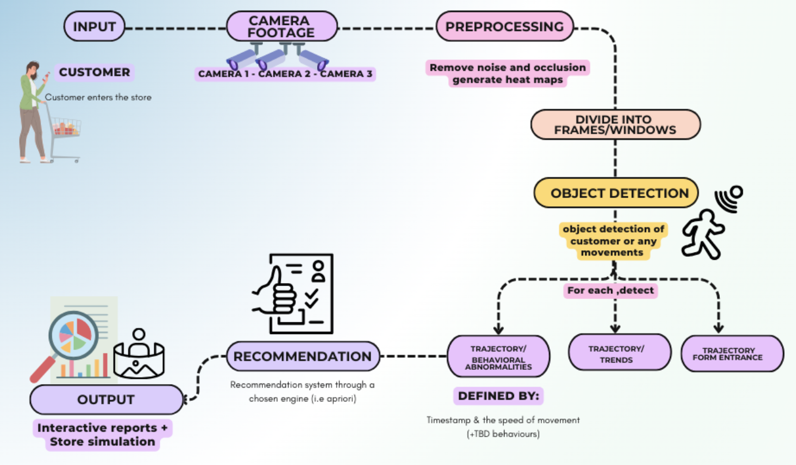

*Figure 5*

## Models Applied

**YOLO**

The YOLO v7 algorithm was used primarily to track customer trajectories within the retail store. Secondarily, the algorithm was used to record customer paths during a certain duration within the video.

The feature most useful within the application described was YOLO v7’s ability to generate a combined heatmap of several different customer walking paths within retail stores. The model achieves this by overlaying the paths of multiple unique customers onto a single selected map of the store, with areas of higher customer traffic represented by warmer, red colors. This provides a visual representation of customer behavior and movement patterns, which proved invaluable for store layout optimization, product placement, and other retail analytics applications. The easily understood nature of the heatmap proved appealing to supermarket vendors, since it required no technological or analytical background to be understood and comprehended[6].

The algorithm was effective in tracking customers in order to generate a combined heatmap of several different customer walking paths within retail stores. Combined with a feature to be implemented to record customer time spent in front of products when the algorithm detects absence of movement, the YOLO algorithm proved to be versatile and highly applicable to the case at hand when adjusted correctly.

**DBSCAN**

The DBSCAN (Density-Based Spatial Clustering of Applications with Noise) model is a popular unsupervised learning method utilized in model building and machine learning algorithms. It was proposed by Ester et al. in 1996[7]. The algorithm aims to find and expand dense areas within data to find arbitrarily dense data points[8].

One of the key advantages of the DBSCAN model is its capability of sorting multiple data points into segmented clusters. This feature is particularly useful in applications such as image segmentation, where the model proves very efficient in being used to segment images based on pixel density, enabling more accurate image analysis. For the application described, the increase in image computation accuracy proved to be fitting in the differentiation of customers and their different appearances.

The DBSCAN model was researched to be used in data cleaning upon collection and the calculation of customer density within certain areas. The model itself works by dividing data points into clusters, allowing analysis to be done on certain areas only, minimizing the distortion outliers created on normal customer behaviors.[9]

**CNN**

The Convolutional Neural Network model was applied in order to classify behaviors. As aforementioned, they consist of dwelling, passing-by, being impressed, bending down, returning item and reaching for product. The model was first practiced on vehicle classifications such as motorcycles and cars, followed by frame by frame groupings to classify behaviors. The model showcased a high accuracy of 0.91 with no over or under fitting however still being trained for more significant results. The model was also supported by similar research from 2019 which also emphasizes on the practicality of the CNN model for this purpose[10].

**Markov**

A mathematically complex model like the Markov model proved very interesting within the application at hand.

Markov models have found wide applications in various diverse fields. For instance, they are used in machine learning for predicting speech and uttered words [11], in finance for foreshadowing stock price movements [12], and in engineering physics for modeling processes like Brownian motion [13]. They are also used in fields like economics, zoology, medical and data science1. What these applications have in common is the need for a model that tracks past action and movement in order to predict further movement. For the application at hand, this has proven to apply sufficiently to customer behavior tracking in order to understand their past movements and predict movements based on their history.

To simplify how the model functions, the Markov model is a mathematical method for systems that possess the Markov property. The property states that any event at a certain time is only dependent on the event directly occurring before it, disregarding any other previous steps. Within the application at hand, the Markov model was practical in tracking customer paths and trajectories based on the last paths they took, making prediction much simpler[14].

## Final Output

The final output of the models should be a data-rich, interactive soft-copy report submitted to clients monthly. The reports include a heatmap of customer movements, recommended product placements built upon the models’ analysis of store grounds and customer behaviors, and an interactive product placement display to help in visualizing the effect different product placements would have on sales.

The report should be easy to understand for non-technologically-savvy individuals, but also full of data to allow for easy business decisions to be made and the diffusion of any confusion offered by charts and graphs. If the customers prefer a different method of delivery, the reports can be converted to hard-copy graphs and charts to fit the vendors’ needs.

# Experiments

In this section, the performance of demos are analyzed in order to examine and evaluate the process of putting together the framework. (please provide a clear understanding of what to add differently from the Models section)

# Usability

The proposed product is a framework for customer behavior analysis within retail stores, mainly at the moment hypermarkets. The consumer would need to specify their businesses resources and needs for the product to be fixed and maneuvered accordingly. For instance, if a non-technical department would be the user then the framework would need to be applied to a front-end and back-end with UI integration, therefore an app or a web app or both, depending on the demands. The product would also requisite to be fine-tuned to meet the business scope and requirements. On the other hand, if the users are a technical department or individual hereby the product is ready to be used and altered for the entity’s needs.

# Challenges

In the environment of hypermarkets, one of the most prominent challenges is the software’s capacity to differentiate between various customer behaviors. At first, there were three behaviors noted as the only ones needed to be classified, which are: *dwelling*, *impressed* and *passing-by*. Dwelling is identified when the shopper extends their stay at a certain point. An impression is made through a shorter-termed pause at a given point. A passing-by is the act of a shopper aimlessly walking. After multiple demos conducted of different models, more behaviors were noticed that would need to be included as well for a more accurate framework and analysis, such as the motions of *grabbing + returning object* and *grabbing + taking object*. Just as well, other animalistic behavior may be introduced on rare occasions, such as theft or any other suspicious activities. This necessitates an extra anomaly detection algorithm or classifier using unsupervised learning. Knowing the wished outcome, moving forward, the challenges would be well understood.

As an initial challenge, the granularity required to discern subtle shifts in behavior, as the ones stated before, requires advanced computer vision tools and algorithms. The CNN model becomes quite imperative to be applied in order to help focus on key regions among frames, thus enhancing the model’s accuracy and ability to reach an acceptable outcome[15]. In addition, the Markov model proves valuable in regulating this challenge since it can be employed to capture temporal dependencies in sequential frames which enables the system to detect patterns and predict the type of behavior[16] . Furthermore, curating a large and diverse dataset for a more enhanced learning model was found to be a tiny challenge. There are not enough libraries curated of hypermarket or supermarket footage, which suggests the team would have to gather its own database.

As aforementioned, an anomaly detection algorithm is necessary for the longevity and accuracy of the framework. Autoencoders can be implemented to help identify deviations which detect abnormal behavior. Since it is crucial for such algorithms to balance between specificity and sensitivity, reinforcement learning and the fine-tuning of hyperparameters becomes crucial. Overall, this fortifies the system against false positives and negatives [17].

Lastly, in order to employ a comprehensive behavior analysis, the system’s cameras would be required to efficiently track customers across a large network of cameras within the given environment. This poses a large challenge since many challenges are foreseen to be met, such as occlusions and many inaccuracies. Nonetheless, a proposed solution is to employ multi-object tracking algorithms. It also entails a robust integration of computer vision techniques. Understanding the customer’s journey from entry to exit necessitates more than basic technicalities. The system should be prompted to balance between maintaining individual identities and producing a collective comprehensive analysis of all behaviors. Additionally, this warrants the adoption of privacy following data collection since ethical values come as a priority.

In summary, the challenges discussed require the employment of multiple additional models and algorithms for a more holistic understanding of customer dynamics. They would not affect the system’s ability to produce the final output as a whole. However, they affect the model’s accuracy levels and may impact it greatly on rare occasions.

# 

# Conclusion

In conclusion, the topic of customer behavior analysis in hypermarkets represents a significant leap forward in product placement optimization and innovating marketing strategies for the business. The proposed framework presents tools for an advanced surveillance system with object detection models and solutions that will help suggest product placements and recognize seasonal trajectory trends. Notable studies were written and mentioned have helped in understanding and employing demos in order for the framework to come into fruition.

Using the knowledge of past implementations, a pipeline of models were chosen for application; YOLO v7, DbScan, CNN and Markov. Certainly, the exclusive use of the in-store CCTV cameras encourages the objective of a non-invasive and practical implementation of the product to the consumer. Just as well, the report is being planned to be straightforward and detailed enough to make well-informed decisions. While challenges persist, the ways in which to overcome them are varied and numerous. Nevertheless, this framework is a substantial beginning point for a data-driven era in this sector and a helpful insight for other fellow software engineers and programmers to build upon.

##### References

1. Teknomo, Kardi, et al. “Pedestrian Static Trajectory Analysis of a Hypermarket.” *Proceedings of the Eastern Asia Society for Transportation Studies*, vol. 7, Jan. 2009
2. Farley, Patrick, et al. *Overview: Monitor Dwell Time in Front of Displays - Azure AI Services*. 18 July 2023,<https://learn.microsoft.com/en-us/azure/ai-services/computer-vision/use-case-dwell-time>.
3. Katanyukul, Tatpong & Ponsawat, J.. (2017). Customer Analysis via Video Analytics: Customer Detection with Multiple Cues. Acta Polytechnica Hungarica. 14. 187-207. 10.12700/APH.14.3.2017.3.11.
4. D. A. Mora Hernandez, O. Nalbach and D. Werth, "How Computer Vision Provides Physical Retail with a Better View on Customers," 2019 IEEE 21st Conference on Business Informatics (CBI), Moscow, Russia, 2019, pp. 462-471, doi: 10.1109/CBI.2019.00060.
5. Sharma, A. (2023, November 20). How to master the popular DBSCAN Clustering algorithm for machine Learning. Analytics Vidhya. <https://www.analyticsvidhya.com/blog/2020/09/how-dbscan-clustering-works/>
6. S. Peker, A. Kocyigit and P. E. Eren, "An empirical comparison of customer behavior modeling approaches for shopping list prediction," 2018 41st International Convention on Information and Communication Technology, Electronics and Microelectronics (MIPRO), Opatija, Croatia, 2018, pp. 1220-1225, doi: 10.23919/MIPRO.2018.8400221.
7. Leonard, L. C. “Chapter One - Web-Based Behavioral Modeling for Continuous User Authentication (CUA).” *Advances in Computers*, edited by Atif M. Memon, vol. 105, Elsevier, 2017, pp. 1–44. *ScienceDirect*,<https://doi.org/10.1016/bs.adcom.2016.12.001>.
8. Bai, Yifan, et al. “An Improved YOLO Algorithm for Detecting Flowers and Fruits on Strawberry Seedlings.” *Biosystems Engineering*, vol. 237, Jan. 2024, pp. 1–12. *ScienceDirect*,<https://doi.org/10.1016/j.biosystemseng.2023.11.008>.
9. Yamashita, R., Nishio, M., Do, R.K.G. et al. Convolutional neural networks: an overview and application in radiology. Insights Imaging 9, 611–629 (2018). <https://doi.org/10.1007/s13244-018-0639-9>
10. Ferracuti, N., et al. “A Business Application of RTLS Technology in Intelligent Retail Environment: Defining the Shopper’s Preferred Path and Its Segmentation.” *Journal of Retailing and Consumer Services*, vol. 47, Mar. 2019, pp. 184–94. *ResearchGate*,<https://doi.org/10.1016/j.jretconser.2018.11.005>.
11. Drabo, Emmanuel F., and William V. Padula, 'Introduction to Markov modeling', in David Bishai, Logan Brenzel, and William Padula (eds), Handbook of Applied Health Economics in Vaccines, Handbooks in Health Economic Evaluation (Oxford, 2023; online edn, Oxford Academic, 20 Apr. 2023), https://doi.org/10.1093/oso/9780192896087.003.0022, accessed 14 Jan. 2024.
12. Chandola, Varun & Banerjee, Arindam & Kumar, Vipin. (2009). Anomaly Detection: A Survey. ACM Comput. Surv.. 41. 10.1145/1541880.1541882.
13. D. Myers, L. Wallin, and P. Wikström, “MVE220 Financial Risk: Reading Project An introduction to Markov chains and their applications within finance Group Members.” Available: <http://www.math.chalmers.se/Stat/Grundutb/CTH/mve220/1617/redingprojects16-17/IntroMarkovChainsandApplications.pdf>
14. J. Daniel and J. Martin, “Speech and Language Processing,” Jan. 2023. Available: <https://web.stanford.edu/~jurafsky/slp3/A.pdf>
15. “Notes 28 : Brownian motion: Markov property.” Available: <https://people.math.wisc.edu/~roch/grad-prob/gradprob-notes28.pdf>
16. Martin Ester, Hans-Peter Kriegel, Jörg Sander, and Xiaowei Xu. 1996. A density-based algorithm for discovering clusters in large spatial databases with noise. In Proceedings of the Second International Conference on Knowledge Discovery and Data Mining (KDD'96). AAAI Press, 226–231.
17. K. Khan, S. U. Rehman, K. Aziz, S. Fong and S. Sarasvady, "DBSCAN: Past, present and future," The Fifth International Conference on the Applications of Digital Information and Web Technologies (ICADIWT 2014), Bangalore, India, 2014, pp. 232-238, doi: 10.1109/ICADIWT.2014.6814687.
18. E. N. Kajabad and S. V. Ivanov, “People Detection and Finding Attractive Areas by the use of Movement Detection Analysis and Deep Learning Approach,” Procedia Computer Science, vol. 156, pp. 327–337, 2019, doi: https://doi.org/10.1016/j.procs.2019.08.209.

1. Teknomo, Kardi, et al. “Pedestrian Static Trajectory Analysis of a Hypermarket.” *Proceedings of the Eastern Asia Society for Transportation Studies*, vol. 7, Jan. 2009.
2. Farley, Patrick, et al. *Overview: Monitor Dwell Time in Front of Displays - Azure AI Services*. 18 July 2023,<https://learn.microsoft.com/en-us/azure/ai-services/computer-vision/use-case-dwell-time>.
3. Katanyukul, Tatpong & Ponsawat, J.. (2017). Customer Analysis via Video Analytics: Customer Detection with Multiple Cues. Acta Polytechnica Hungarica. 14. 187-207. 10.12700/APH.14.3.2017.3.11.
4. D. A. Mora Hernandez, O. Nalbach and D. Werth, "How Computer Vision Provides Physical Retail with a Better View on Customers," 2019 IEEE 21st Conference on Business Informatics (CBI), Moscow, Russia, 2019, pp. 462-471, doi: 10.1109/CBI.2019.00060.
5. S. Peker, A. Kocyigit and P. E. Eren, "An empirical comparison of customer behavior modeling approaches for shopping list prediction," 2018 41st International Convention on Information and Communication Technology, Electronics and Microelectronics (MIPRO), Opatija, Croatia, 2018, pp. 1220-1225, doi: 10.23919/MIPRO.2018.8400221.
6. E. N. Kajabad and S. V. Ivanov, “People Detection and Finding Attractive Areas by the use of Movement Detection Analysis and Deep Learning Approach,” Procedia Computer Science, vol. 156, pp. 327–337, 2019, doi: https://doi.org/10.1016/j.procs.2019.08.209.
7. Martin Ester, Hans-Peter Kriegel, Jörg Sander, and Xiaowei Xu. 1996. A density-based algorithm for discovering clusters in large spatial databases with noise. In Proceedings of the Second International Conference on Knowledge Discovery and Data Mining (KDD'96). AAAI Press, 226–231.
8. K. Khan, S. U. Rehman, K. Aziz, S. Fong and S. Sarasvady, "DBSCAN: Past, present and future," The Fifth International Conference on the Applications of Digital Information and Web Technologies (ICADIWT 2014), Bangalore, India, 2014, pp. 232-238, doi: 10.1109/ICADIWT.2014.6814687.
9. Sharma, A. (2023, November 20). How to master the popular DBSCAN Clustering algorithm for machine Learning. Analytics Vidhya. https://www.analyticsvidhya.com/blog/2020/09/how-dbscan-clustering-works/
10. Ferracuti, N., et al. “A Business Application of RTLS Technology in Intelligent Retail Environment: Defining the Shopper’s Preferred Path and Its Segmentation.” *Journal of Retailing and Consumer Services*, vol. 47, Mar. 2019, pp. 184–94. *ResearchGate*,<https://doi.org/10.1016/j.jretconser.2018.11.005>.
11. J. Daniel and J. Martin, “Speech and Language Processing,” Jan. 2023. Available: https://web.stanford.edu/~jurafsky/slp3/A.pdf
12. D. Myers, L. Wallin, and P. Wikström, “MVE220 Financial Risk: Reading Project An introduction to Markov chains and their applications within finance Group Members.” Available: http://www.math.chalmers.se/Stat/Grundutb/CTH/mve220/1617/redingprojects16-17/IntroMarkovChainsandApplications.pdf
13. “Notes 28 : Brownian motion: Markov property.” Available: https://people.math.wisc.edu/~roch/grad-prob/gradprob-notes28.pdf
14. Leonard, L. C. “Chapter One - Web-Based Behavioral Modeling for Continuous User Authentication (CUA).” Advances in Computers, edited by Atif M. Memon, vol. 105, Elsevier, 2017, pp. 1–44. ScienceDirect, https://doi.org/10.1016/bs.adcom.2016.12.001.
15. Yamashita, R., Nishio, M., Do, R.K.G. et al. Convolutional neural networks: an overview and application in radiology. Insights Imaging 9, 611–629 (2018). https://doi.org/10.1007/s13244-018-0639-9
16. Drabo, Emmanuel F., and William V. Padula, 'Introduction to Markov modeling', in David Bishai, Logan Brenzel, and William Padula (eds), Handbook of Applied Health Economics in Vaccines, Handbooks in Health Economic Evaluation (Oxford, 2023; online edn, Oxford Academic, 20 Apr. 2023), https://doi.org/10.1093/oso/9780192896087.003.0022, accessed 14 Jan. 2024.
17. Chandola, Varun & Banerjee, Arindam & Kumar, Vipin. (2009). Anomaly Detection: A Survey. ACM Comput. Surv.. 41. 10.1145/1541880.1541882.